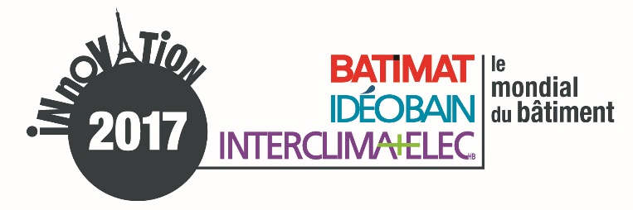

Komunikat prasowy
wrzesień 2017

Laureaci edycji 2017 Konkursu Innowacji zostali ogłoszeni

Jury Konkursu Innowacji wydarzenia Mondial du Bâtiment 2017 oraz targów INTERCLIMA+ELEC_{HB}, IDÉOBAIN i BATIMAT, organizowanych we współpracy z ADEME, ogłosiło listę laureatów tegorocznej edycji. Konkurs potwierdza dużą innowacyjność firm działających na rynku budowlanym.

Obradujące 6 września br. Jury miało za zadanie wyłonić zwycięzców Konkursu Innowacji w 9 kategoriach. Wybierano spośród 89 nominowanych firm wyselekcjonowanych w czerwcu przez jury ekspertów.
Guillaume Loizeaud, dyrektor Mondial du Bâtiment podkreśla duże zaangażowanie firm. W tym roku do konkursu zgłosiło się 217 kandydatów, jest to wzrost o 10% liczby uczestników w porównaniu z edycją 2015. „Potwierdza to determinację branży oraz chęć szukania innowacji, dzięki którym będzie można jeszcze lepiej budować i remontować”.

Biorąc pod uwagę dużą liczbę i różnorodność uczestników oraz laureatów konkursu Guillaume Loizeaud zauważa, że „3 salony Mondial du Bâtiment będą po raz kolejny platformą prezentacji licznych innowacji oraz idealnym miejscem do ich odkrywania, dzięki specjalnym przestrzeniom i ścieżkom zwiedzania”.

Innowacyjne produkty będą przez 5 dni prezentowane podczas wydarzenia Mondial du Bâtiment :

W Przestrzeniach Innowacji targów
Odwiedzający Mondial du Bâtiment będą mieli okazję odkryć, dotknąć i zapoznać się z produktami wyróżnionymi w Konkursie Innowacji 2017.
Trzy nowe Przestrzenie Innowacji zostaną zaprezentowane w ramach trzech salonów INTERCLIMA+ELEC_{HB}, IDÉOBAIN i BATIMAT. Innowacyjne produkty będą codziennie prezentowane podczas pokazów, dzięki czemu profesjonaliści będą mogli w pełni poznać ich zastosowanie.

W ramach ścieżek innowacji
Specjalnie oznakowane ścieżki pozwolą odwiedzjącym w łatwy sposób odnaleźć firmy, które brały udział w Konkursie Innowacji.
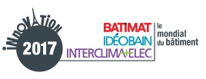

LISTA LAUREATÓW KONKURSU INNOWACJI 2017

STRUCTURE & ENVELOPPE

GOLD WINNER | SUNPARTNER TECHNOLOGIES | WYSIPS® CAMELEON  The aesthetic photovoltaic facade
SILVER WINNER | MISAPOR | MISAPOR GREENLIGHT 10/63  The lightweight embankment
BRONZE WINNER | MECD | DEMODULOR  Valuable and designed for disassembly construction systems

JOINERY & FENESTRATION

GOLD WINNER | DR. HAHN | HAHN TÜRBAND INDUCTIO®  The smartest door hinge by far
SILVER WINNER | OTIIMA - FRAME SYSTEM | OTIIMA 38 FUSION SYSTEM  Much more than a window
BRONZE WINNER | TECHNAL - SAPA BUILDING SYSTEMS | FENÊTRE SOLEAL OPTIMIZED  The window RBR 2020 : more performance with a standard 65mm aluminum module
Dans cette catégorie, 2 produits nominés ont reçu une Mention Spéciale du Jury :
SPECIAL MENTION  DESIGN | SKY-FRAME | SKY-FRAME SLOPE  The inclined sliding door
SPECIAL MENTION  COMBINATION OF SKILLS | VELUX FRANCE | VELUX ACTIVE WITH NETATMO  The smart sensor-based home solution for better indoor climate

INDOOR FITTINGS

GOLD WINNER | PLACO® – UNE MARQUE DE SAINT-GOBAIN | HABITO®  The wall that meets all the challenges of everyday life
SILVER WINNER | FRANCEINNOV | BIOACTIV +  The thermoregulating coating which absorbs, stores and restores the energy
BRONZE WINNER | DEHONDT COMPOSITES | NATTEX PANEL  The bio-sourced sandwich panels

OUTDOOR FITTINGS

GOLD WINNER | ONLEVEL | KRONOS  The first adjustable glass clamp ever
Dans cette catégorie, 1 produit nominé a reçu une Mention Spéciale du Jury :
SPECIAL MENTION  ENVIRONMENTAL  INTEGRATION | PISCINES DESJOYAUX | MOBIPOOL  The very first floating swimming pool in the world

WORKSITE EQUIPMENT & TOOL

GOLD WINNER | MESSER EUTECTIC CASTOLIN | DYOMIX® OHM 2.4  The innovative, mobile, safe oxy-flame station without gas cylinders!
SILVER WINNER | DRONE VOLT | HERCULES 10 SPRA  Spray Drone for buildings
BRONZE WINNER | ALSAFIX | LIGNOLOC®  The nails made of wood for pneumatic nailer
Dans cette catégorie, 1 produit nominé a reçu une Mention Spéciale du Jury :
SPECIAL MENTION  SAFETY & PREVENTION | ROLIDE | ROLIDE  The sliding floors for commercial vehicles

DIGITAL, BIM & NEW TECHNOLOGY

GOLD WINNER | LEICA GEOSYSTEMS | LEICA BLK360 IMAGING SCANNER  Imaging laser 3D scanner that anyone can use
SILVER WINNER | ABVENT | TWINMOTION 2018  The real-time Archviz and VR exploration software
BRONZE WINNER | DOKA FRANCE | CONCREMOTE  The real-time concrete on-site monitoring solution

HVAC

GOLD WINNER | LUFTMEISTER | LUFTMEISTER  The system which distributes ventilation costs by measuring energy consumption
SILVER WINNER | UBBINK FRANCE | ROLUX RENOFIT®  The horizontal terminal for renovation Ø60/100
BRONZE WINNER | WEISHAUPT | WM-G20 ZM-PLN  The premix Ultra Low Nox burner

RENEWABLE ENERGIES SYSTEM

GOLD WINNER | AIRMAT | COMPACTE ÉNERGIE +  The air/water heat pump with free hot water in cooling mode in the summertime

BATHROOM PRODUCTS

GOLD WINNER | SFA | SANIPRO® XR UP  The macerator that allows the creation a new bathroom, anywhere
SILVER WINNER | GROHE | GROHE SENSE GUARD  The devices detect, leaks, pipe breaks and floods - Before a drip becomes a flood
BRONZE WINNER | NICOLL | DOCIA®-XS SFH AVEC TECHNOLOGIE MAGNETECH  The first compact trap for tiled shower, with the patented magnetic technology

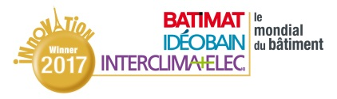
STRUCTURE & ENVELOPPE

Company | SUNPARTNER TECHNOLOGIES
Product name | WYSIPS® CAMELEON  The aesthetic photovoltaic facade
Target | Architects, Project owners
Patent | Pending | Certification | Pending
Lauch date | November 2017

Product description

Wysips® Cameleon is an aesthetic photovoltaic façade cladding solution to activate the facade. It offers to architects a high design freedom; it is a revolution in solar architecture. This Cameleon facade module comes in various patterns and colors, so there is no need to choose between function and architectural design. With Wysips® Cameleon, architects and façade makers can address new solar surfaces in addition to the usual roof surface. That way, all building surface can generate energy, helping constructions to reach green building certifications (RE 2018 BREEAM, LEEDS, HQE, etc). Into façades, spandrels, cladding panels, the Cameleon solution offers nearly invisible PV cells, various design possibilities, and high design freedom for architects.

Available modules are single laminated glass, ready to be integrated. The module is 10,5mm thick, his format is 659 x 1582 mm, and his weight 28 kg. The type of solar cells is CIGS (thin-film material made of copper, indium, gallium, selenide). It is made with an EVA interlayer. Junction boxes are at the back of the module, with cables. The cover glass is customizable (thickness, coatings). Cameleon produces 100 Wp/m² (Standard Test Conditions), performance varies with design options, offering more than 80% of standard photovoltaic panel performance. Cameleon exists in complete façade solution (cladding and photovoltaic connection).

In addition to its functional façade, our Cameleon solution is active and produces energy. To match the new regulations, in terms of renewable energy production, it is required today to install solar cells not only on the roof but also on façades. The energy balance of the building is then reduced; the enery produced will be used in a self-consumption system (authorized by law) or connected to the grid.

New energy efficiency regulations require buildings to incorporate renewable energy technologies (Nearly-Zero Energy Building). Wysips® Cameleon solution activates façade surfaces avoiding typical solar panel designs (typical square crystalline cells design). Moreover, this solution is customizable: the architect can choose the design. The façade aesthetics is preserved: patterns, colors, textures can be realized.

Cameleon solution brings an additional function to the façade, as it produces energy, in addition to its basic function. Moreover it matches the architect's expectations in terms of design.

Cameleon solution helps to obtain zero energy buildings labels, in particular for non residentials buildings with more than 5 floors, with a high quality aesthetic façade. To obtain these environmental targets with an aesthetic solution is an advantage for the assets value (resel price, rental price) and a lower depreciation.
The Cameleon façade solution is compatible with standard hanging systems. It is a conventional system on metal frame with rail. The installation is simple and standard in ventilated façade. The electrical connection between the modules is easy.
No specific maintenance is required.

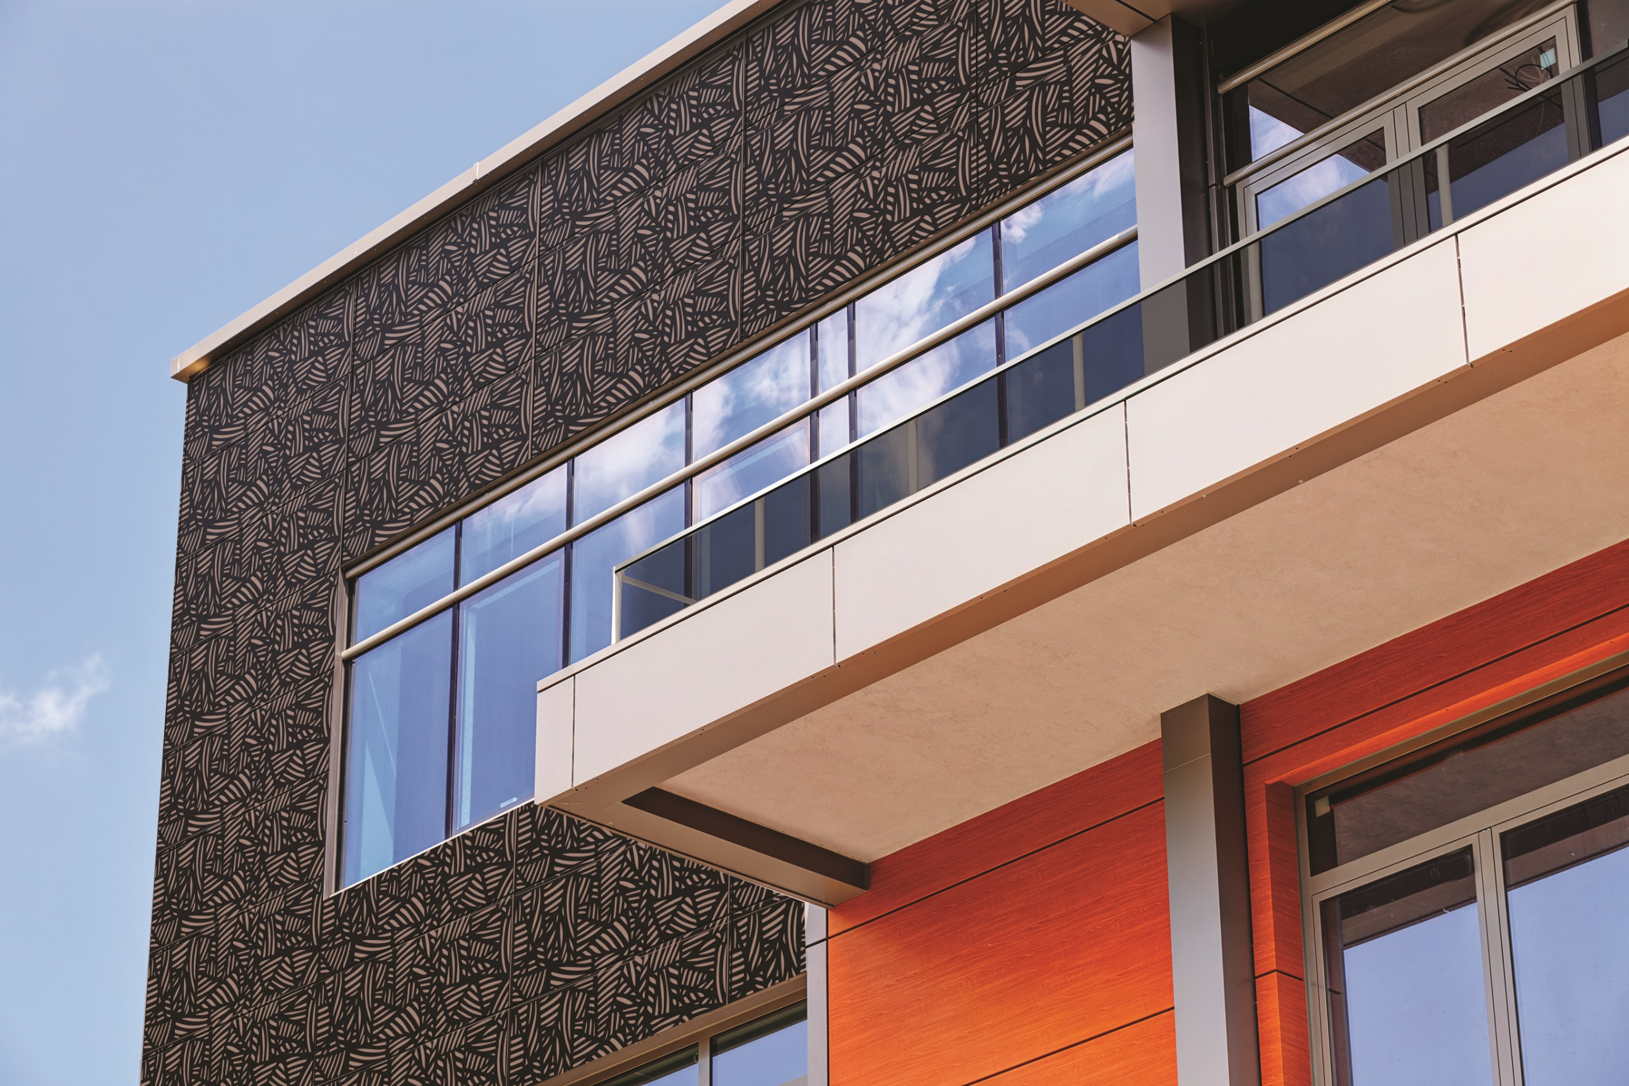

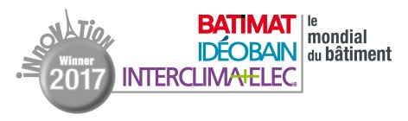
STRUCTURE & ENVELOPPE

Company | MISAPOR
Product name | MISAPOR GREENLIGHT 10/63  The lightweight embankment
Target | Architects, Engineering & design offices, Craftsmen / installers, Construction economists, Structure engineers/geotechnicians/construction companies publics
Patent | Non | Certification | Pending
Lauch date | Janvier 2017

Product description

MISAPOR Greenlight 10/63 is a lightweight cellular glass aggregate backfill made from 98% recycled glass bottle and 2% mineral activator. MISAPOR Greenlight 10/63 is an inert, rot-proof, durable, and easy-to-install granulate. MISAPOR is used for any lightweight fill on structures with carrossable or vegetated areas.

MISAPOR Greenlight 10/63 has a density of 110kg/m3 and is 20 times lighter than a conventional backfill. MISAPOR Greenlight 10/63 has a very good compressive strength, can be an additional insulation on slab and is very easy to put in place. MISAPOR is a solution for every structural engineer when lightening loads on a slab.

MISAPOR Greenlight 10/63 is a solution for any planner or contractor looking for a lightweight backfill to avoid putting weight on a work. MISAPOR is an aggregate with a closed port so it does not absorb water. Its weight remains stable over time. MISAPOR differentiates itself from the other systems currently on the market because it is an ecological, durable, inert and rot-proofed backfill solution.

MISAPOR replaces lightweight solutions such as polystyrene blocks, used tire embankments or expanded clay beads. MISAPOR is an innovative product because it is manufactured exclusively from glass bottles: a high-quality material is produced with a waste product, we talk about upcycling.

In comparison with competitive systems, we are cheaper compared to some solutions and the same price as other solutions. If we analyze the life cycle of the product, especially durability, we are incomparable. MISAPOR is much better since it is an inert material.MISAPOR is easy to install thanks to its extremely low density of 110kg/m3. MISAPOR can be used in the installation phase and saves time and money on site.

It reduces the number of operations by setting up a product instead of 2-3 depending on the alternatives.

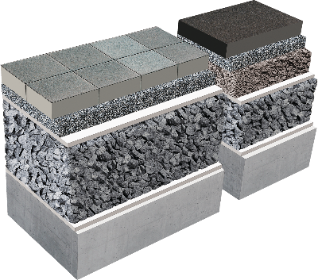

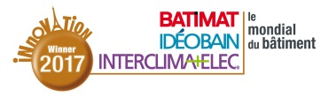
STRUCTURE & ENVELOPPE

Company | MECD
Product name | DEMODULOR  Valuable and designed for disassembly construction systems
Target |  | Architects, Project owners
Patent |  | No | Certification | No
Lauch date |  | 2018

Product description

DEMODULOR is a set of innovative multi-material construction solutions (concrete, wood, steel, terracotta) that includes the deconstruction (or refurbishing) of future buildings and constructive solutions for the prevention of waste production through a systematic demolition approach, it facilitates: separation of systems and components onsite, separation of materials for optimized elimination or recycling, reuse of materials and components.

Four different and combinable systems were developed: brick-built prestressed wall with steel, steel-wood-concrete dry floor, concrete and steel composite floor, timber facade with steel strips. Brought together, those systems are dedicated to residential and office buildings.

The DEMODULOR multi-materials solutions supports the relevant use of a material for its intrinsic properties with the aim of optimizing the complete constructive system and so guaranteeing the performance of the initial work and its later lives. For the global set of life cycle steps, these systems which can be dismantled are considerably more advantageous than their traditional equivalents on the environmental, sanitary and security aspects, while keeping the required initial functions. This is the first eco-design of building frame and enveloppe allowing an answer to resources management and circular economy.

The easy dismantling process allows the waste separation or the re-use of components in case of partial or total demolition, and the adaptability of these elements in case of renovation or building evolution. Every component used in just quantity improves significantly the LCA assessment of the works and participate actively in the economy of natural resources and in the conservation of the planet.

The demountable systems use current prefabricated components and favor dry connections. The limited " liquid " phases lead to a facilitated implementation, respectful of the practised techniques. On a cleaner construction site, the prefabrication and the in situ assembly gives their definitive properties to the works, in particular mechanical, and contribute to the safety on site

No complementary specific maintenance is to be planned on these works compared to the traditional systems. But the phase of dismantling is incomparable: disassembly processes are simply back to front as opposed to construction and those bring benefits on the safety and comfort conditions. The economic profit is expected from the valuation of the dismantled components.

By choosing reusable constructive systems, the project developer increases his credibility on its CSR policy and gives a greater green value to the building. In equivalent construction cost to a traditional technique, he grants himself the flexibility of evolution at a managed cost. At the resale moment, he makes sure of an added value in a context always more concerned about the conservation of natural resources.

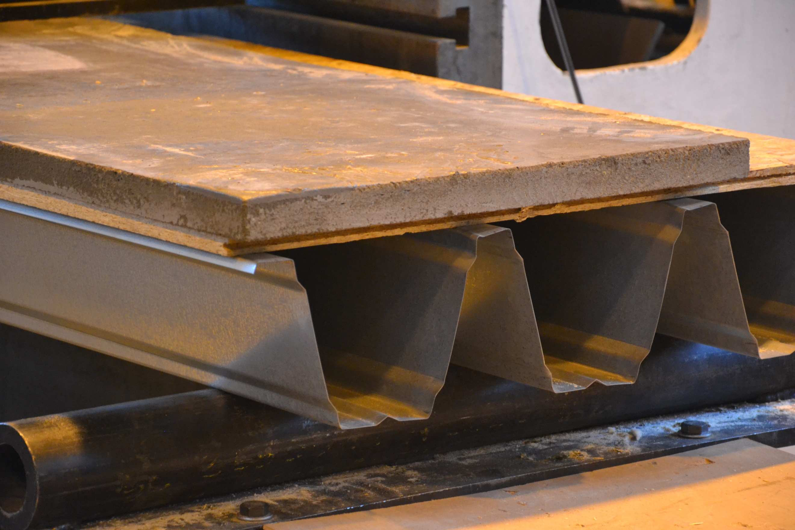

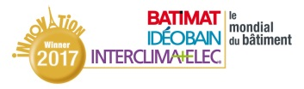
JOINERY & FENESTRATION

Company | DR. HAHN
Product name | HAHN TÜRBAND INDUCTIO®  The smartest door hinge by far
Target | Architects, Engineering & design offices, Craftsmen / installers
Patent | Yes | Certification | G115080 (EN 50131)
Lauch date | September 2016

Product description

The Hahn Türband 4 Inductio® is an energy and signal conducting element for electronically secured steel and aluminium frame doors, distinguished by the roll look a three-piece screw-on hinge. A new path for wireless and bidirectional transmission of signals, which is certified in accordance with the European standard EN 50131(For Germany: VdS Class C) and is intended for connecting a central alarm system with consumers at the door without a cable transition. The Inductio® makes it easier for door manufacturers and installers of safety installations to route cables along doors and connect access control systems and alarm systems. There are currently no other product that wirelessly conduct energy and signals and which may be used in security restricted areas in accordance with the aforementioned standards. Inductio® is suited for all doors installed in public accessible rooms with high requirements on electronic security (banks, jewellery stores, regulatory authorities, companies).

As the name Inductio® suggests, induction was selected as the functional principle. In this context, coils are used to generate high-frequency magnetic fields. An electrical voltage is induced and energy and/or signals can be transmitted bidirectionally. A conventional cable transition, as is commonly used to date, starts showing signs of wear after approx. 20,000 cycles. Inductio®, on the other hand, has been subjected to testing with 10,000,000 opening cycles, and no adverse effects were noted with regard to functionality and the transfer of energy and signals. There are no cable connections between door and frame thanks to the electrically isolated transmission path. Cyclical self tests ensure a continuous monitoring of complete functionality. Inductio® is equipped with a tamper contact, which is generally in operation. All pivot points, borehole gauges and colour versions of the Hahn Türband 4 series, 3-piece, have the same look as Inductio®.
Frame and door can be processed separately. Even when in service, the door leaf can be mounted and taken off its hinges without extensive disassembly of the wire junctions and wire caps. The door design seems to be one piece, since the look of the Hahn Türband 4 Inductio® is identical with that of the door hinge, where the Türband 4 Inductio® does not bear any loads. It is suited for conducting 12 or 24V DC in order to operate commercially available motorised locks or light systems at the door.
The Inductio® system is a new and globally unique path for wireless and bidirectional transmission of signals, which is certified in accordance with EN 50131 and is intended for connecting a central alarm system with consumers at the door without a cable transition. The door leaf can be easily installed and removed, since it is not necessary to loosen and re-install any fixed cable connections.
Inductio® is globally unique, without any comparable commercially available versions in terms of technology. In particular, the approval in the VdS-C segment and EN 50131 for doors with especially high demands on security is unique as means for wireless transmission of signals and energy. In this regard, there are no comparable products in terms of pricing.
An Inductio® can replace up to three cable transitions, while preserving the look of the doors. In addition, potential attackers cannot locate the path of transmission of signals and energy from the outside, since Inductio visually resembles the Hahn Türband 4. Once Inductio® has been installed, it can easily withstand at least 10 million opening cycles. A conventional cable transition will give way after approx. 20,000 cycles and must be replaced.
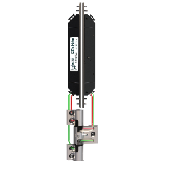
JOINERY & FENESTRATION
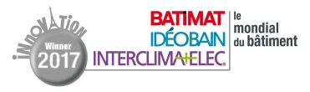

Company |  | OTIIMA - FRAME SYSTEM
Product name |  | OTIIMA 38 FUSION SYSTEM  Much more than a window
Target | Architects, Engineering & design offices
Patent | Pending |  | Certification | Pending
Lauch date | April 2017

Product description

Imagine a sliding window with no visible frame profiles - it is what OTIIMA 38 FUSION SYSTEM offers you - a system completely built-in on the finish materials, as if the window were merged with the building, becoming only one. Beyond that, the fusion system incorporates a drainage profile channel, able to drain a large amount of rainwater, even in extreme rainfall situations. The fusion system achieved exceptional result in watertightness test, with an outstanding e1650 class (seven classes above the class 9a), according en 12208 + iso en 1027.

OTIIMA 38 FUSION SYSTEM incorporates rim profiles with reinforced binding polyamides and toughened glass (glazed panes up to 23 sqm) providing superior thermal and structural performances. The central vertical mullions with only 20mm thickness are prepared to ensure an excellent performance (thermal, water and air tightness). The vertical double bearings sliding system integrates also additional horizontal bearings that ensure the perfect stability of the glazed panes. OTIIMA 38 FUSION SYSTEM incorporates a drainage profile channel, able to drain a large amount of rainwater, even in extreme rainfall situations. The thermal transmittance performance is up to uw=1.0 w/m2.ºk (ug=0.7); watertightness: e1650 (exceptional class); air permeability class 4; wind resistance: up to class c5; impact resistance: class 5; acoustic insulation: rw up to 44db; security: up to rc2(wk2).
This fusion system presents the perfect balance between aesthetics, with the minimum use of visible aluminum profiles, with the best watertightness performance (best performance class in the world in the market of minimalist windows, without using electromechanical systems).
OTIIMA 38 FUSION SYSTEM is innovative, and the only known existing system, which is completely built-in on the four sides of the frame, allowing the perfect fusion and continuity between interior and exterior space. Beyond that, it is the only system that uses horizontal stabilizers, and also a fully integrated drainage system. It fully integrates with any building material, thanks to its modular drainage profile. It also accomodates solar protection rolls and screens, shading blinds and retractable anti-mosquito nets.
Compared to the direct competitors in the market of minimal frame windows, the prices are equivalent, although it is a much more evolved system.
The advantages for the final user is probably to enjoy maybe the most practical and beautiful window of the market which offers: the superior design and aesthetics, the maximum light and transparency, the high security, the high comfort and the easy maintenance, which make it the perfect choice for any use.
OTIIMA 38 FUSION SYSTEM is a window system composed by profile modules that allow an easy installation. The system is installed step by step, from the inside out, like a “lego system”. The uninstallation, in case of need of maintenance, also becomes easy using the same steps.
There is a possibility of maintenance related to the eventual need to remove a broken glass, or just for a simple cleaning intervention, thanks to the central profile slot that is completely removable.

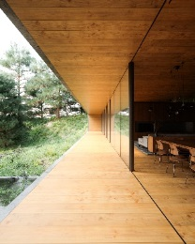

JOINERY & FENESTRATION

Company | TECHNAL
Product name | FENÊTRE SOLEAL OPTIMIZED  The window RBR 2020 : more performance with a standard 65mm aluminum module
Target |  | Architects, Craftsmen / installers, Project owners
Patent |  | Pending | Certification | Pending
Lauch date |  | March 2018

Product description

Soleal Optimized, a concentrate of performances and characteristics never encountered on a window with a standard 65 mm module. It guarantees high thermal, acoustic and sealing performance at an optimized price. This window has better performance than a 75 mm module while offering a concealed sash design at a 65 mm-module window price. With a carbon footprint as low as possible, matching the RBR 2020, It is an ideal window for the installation in renovation. It is also designed to offer ease of manufacture and adjustments for the installer.

With a module of only 65 mm, the window achieves thermal performances normally reserved for windows using a 75mm-module and beyond. The Uw coefficient is thus improved by 0.2W / (m².K), making it possible to be qualified for Passivhaus (Uw of 1.2 W / m².K with a glazing Ug = 1.0 and 1.3 W / m².K with glazing Ug = 1.1). Its acoustic performance RA, tr exceeds 35dB with a monolithic glazing. This gain is achieved by making the sound attenuation of the window more homogeneous according to the frequencies. The acoustic comfort is therefore increased. All this is achieved by maintaining ease of manufacture and adjustment thanks to the adhesive bonding of the glazing and to the important play between the sash and the frame. The concealed sash design offers fine and elegant profiles which maximize the solar contributions. and reduce heating and electricity consumption.
It is a window with high-end positioning (exceptional performance in accordance with the RBR 2020) at an optimized price. Up to now, reinforcing the performance of a window always meant increasing the thickness of module and adding technical elements (shields, foams, etc..). For this window, the brand has adopted choices that revolutionize the current renovation market (depth of 65 mm adapted to the replacement of woodwork).
The design has been optimized the bonding of the glazing makes it possible to optimize the thermal insulation by minimizing the exchanges in the rebate area. A patented acoustic damper and the fastening ot the glazing generate an acoustic gain over a wide range of frequencies.
The fact of offering such a level of thermal performance with a 65mm module sets the cost of Soleal Optimized favorably compared with competing solutions. Moreover, the acoustic performance is achieved without using laminated glazing which is still very expensive. The ease of manufacture and installation are also sources of savings for the installer.
The combination of good acoustic and thermal performances, and increased solar and light gains at the price of a window in 65 mm modules and not 75 or even 95 mm. The end user benefits from the same design as the SOLEAL range (sliding and door). The consumer can also change his small modules wood joinery without changing the structure of the frame and obtaining RBR 2020 performance.
Contrary to the current trend of product development, performance improvement has not been achieved by making the design more complex with shields or other sophisticated elements. Manufacturing tolerances have also been increased, resulting in a simpler production. The bonding of the glazing also allows simple and reliable adjustment in the workshop and facilitates installation.
Less risk of adjustment going wrong during the life of the product means less service intervention. The replacement of the glazing in case of breakage, although simplified by the use of a tape technology, may be a new possibility of intervention.
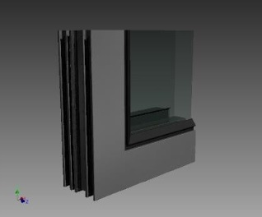

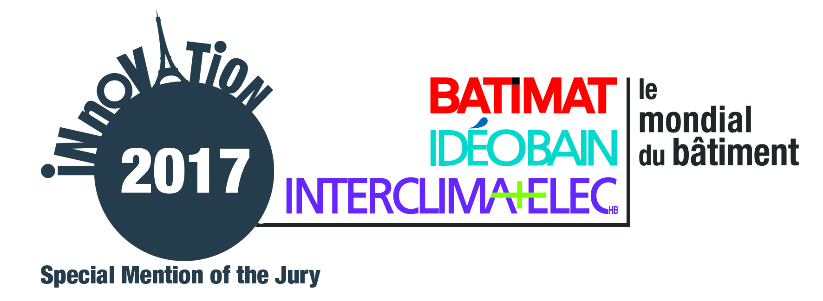
JOINERY & FENESTRATION

Design

Company | SKY-FRAME
Product name | SKY-FRAME SLOPE  The inclined sliding door
Target |  | Architects, Project owners
Patent |  | No | Certification | Yes
Lauch date |  | December 2015

Product description

Sky-Frame Slope sliding windows can be installed with an inward or outward inclination depending on requirements. The system meets all Sky-Frame standards while generating a distinctive spatial geometry. The bearing assembly is able to accommodate all vertical and horizontal forces, thereby achieving superior running performance. Regardless of inclination, the drainage system meets all driving rain resistance requirements.

For the first time Sky-Frame sliding windows are also available with an inward or outward tilt of up to 20° from the vertical. Regardless of the tilt, the system drainage meets all driving rain resistance requirements. The System meets all Sky-Frame standards while generating a distinctive spatial geometry. The bearing assembly is able to accommodate all vertical and horizontal forces, thereby achieving superior running performance. Sky-Frame Slope presents fresh options for the design of customized spatial concepts. The addition of Sky-Frame Slope to the Sky-Frame sliding window range has expanded the design scope for creative living concepts. The sloping glass front combines aesthetic appeal with spectacular views and a unique spatial experience.

Regardless of inclination, the system drainage meets all driving rain resistance requirements. The System meets all Sky-Frame standards while generating a distinctive spatial geometry. The bearing assembly is able to accommodate all vertical and horizontal forces, thereby achieving superior running performance. Slope is available in double or tripple glazing. Both offer full thermal insulation and UV protection.

Sky-Frame Slope is the first frameless tilted sliding door on the market.
The Slope system allows the sliding windows to be installed at an angle. The glass fronts can be incorporated with either an inward or outward inclination. The distinctive spatial geometry offers a unique living experience.

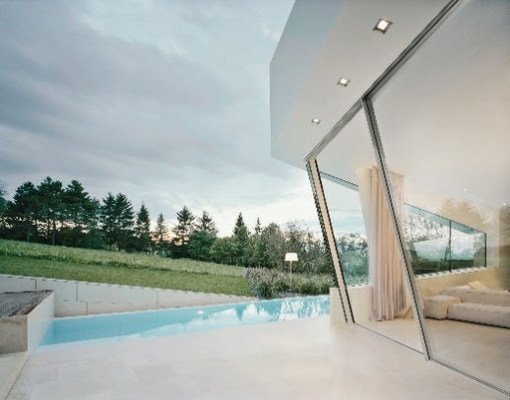

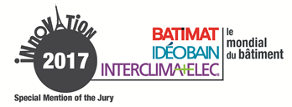
JOINERY & FENESTRATION

Combination of skills

Company | VELUX FRANCE
Product name | VELUX ACTIVE WITH NETATMO  The smart sensor-based home solution for better indoor climate
Target | Craftsmen / installers, End-user
Patent | Pending | Certification | Pending
Lauch date | 2018

Product description

VELUX ACTIVE with Netatmo is a smart sensor-based home solution that automates the opening, closing and shading of VELUX roof windows to deliver a better indoor climate. It automatically regulates temperature, humidity and CO2 levels, which keeps indoor air healthy at all time. VELUX ACTIVE with Netatmo is a fully automated system, but can also be operated with a simple remote or through an intuitive smartphone app. VELUX ACTIVE with Netatmo is in the process of applying for the official Apple HomeKit approval.

VELUX ACTIVE with Netatmo consists of an internet-connected gateway, a wireless climate sensor that measure temperature, humidity, and CO2; a departure switch and a smartphone app. The climate sensor takes benefit of three individual control algorithms to optimize the indoor climate. It delivers daily air recycling, ventilation in case of excessive temperature, humidity or CO2 levels, and it uses local weather forecasts to prevent overheating of room. The departure switch ensures closing and securing of all the electrical VELUX INTEGRA roof windows by one press when leaving the house. The intuitive smartphone app enables remote control of the electrical VELUX INTEGRA roof windows, blinds and roller shutters; and remote monitor and control of indoor climate.
Experience optimum convenience and comfort in your indoor environment through automatic regulation of temperature, humidity and air quality. You do not have to worry about when to air out your home, VELUX ACTIVE with Netatmo automatically ensures a healthy indoor climate.

VELUX ACTIVE with NETATMO is an automatic and dynamic indoor climate solution that makes your home more intelligent. It automatically provides additional comfort and a healthier indoor environment.
VELUX ACTIVE with Netatmo offers an exclusive solution that automatically ensures a healthy indoor climate without any actions required from the home owner. It automatically measures and regulates temperature, humidity and CO2 levels, which keeps indoor air healthy at all time.

VELUX ACTIVE with NETATMO measure and deliver comfortable indoor temperature, moderate humidity and a healthy CO2 level. Analysis of the indoor temperature and outdoor weather data automatically defines when it is best to air out and for how long. The end user do no longer have to worry about when to air out - it is taken care of by VELUX ACTIVE.

The VELUX ACTIVE with Netatmo solution increases the relevance of installing the electrical VELUX INTEGRA roof windows and make them fully intelligent. The installation of VELUX Active is a plug and play solution and does not require any electrical qualifications.

General upgrades and maintenance of the VELUX ACTIVE system will be pushed directly to the home owner through software updates.

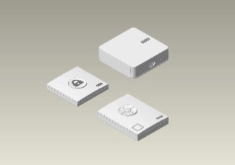

INDOOR FITTINGS

Company | PLACO® – UNE MARQUE DE SAINT-GOBAIN
Product name | HABITO®  The wall that meets all the challenges of everyday life
Target | Architects, Craftsmen / installers, Project owners, Private individuals occupying housing
Patent | Yes | Certification | Pending
Lauch date | March 2017

Product description

In their everyday life, housing occupants expect ever more comfort and freedom. According to a survey carried out by Placo®, they pay special attention in particular to the ease of fixing objects on the walls and their resistance to impacts. This has led Placo® to propose an innovation that will revolutionize the housing market: Habito®, the wall that meets all the challenges of everyday life. Habito® resists to everyday impacts and facilitates fixing of all types of loads. Habito® can be fitted everywhere in the home and it enables the occupants to arrange the spaces according to their wishes.

Habito® stands up to everyday impacts: it prevents all risks of damage during site work (from transport to handling) and in everyday life (door handles, toys, moving furniture around, etc.). Habito® facilitates fixing of all types of loads: it enables fixing of up to 20 kg of loads with just one wood screw and up to 60 kg with an expanding anchor, and without any reinforcement!

Habito® facilitates fixing of all types of loads: it enables fixing of up to 20 kg of loads with a single wood screw and up to 60 kg with an expanding anchor, and without any reinforcement!
Habito® is the only product of its kind on the market; it solves a real problem linked to the resistance to impacts and fixing objects on plasterboard.

First on work sites, the product does not get damaged during transport or installation work. It is also easier to fix heavy objects, since it is no longer necessary to fit reinforcements for a TV, kitchen cabinets or bathroom fittings, etc. And Habito® helps enhance the value of site work, by proposing an innovative product with high added value. All this is achieved thanks to installation techniques that are exactly the same as those for standard boards; there are no changes in fitting habits.

The enhanced strength of Habito® boards helps reduce maintenance operations: its resistance to impacts ensures longer service life and makes it stronger and the possibility of fixing objects with just one screw considerably reduces subsequent filling work.

Habito® is 100% recyclable.
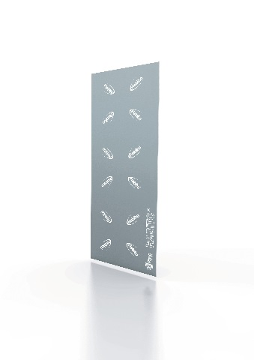

OUTDOOR FITTINGS

Company | FRANCEINNOV
Product name | BIOACTIV +  The thermoregulating coating which absorbs, stores and restores the energy
Target |  | Architects, Engineering & design offices, Craftsmen / installers, Project owners, Construction economists, Wholesalers
Patent |  | Oui | Certification | En cours
Lauch date |  | August 2016

Product description

Bioactiv + is a very thin thermoregulating coating (< 1mm) for walls and floors, designed to improve the thermal comfort and to improve the energy performance of a house. Thanks to phase-changing materials integrated into invisible microcapsules, the coating, which applies to any support, absorbs, stores and then restitutes the heat as soon as the ambient temperature of a room comes down again. In other words, fluctuations in temperature are naturally dampered, thermal comfort and inertia optimized. A comfortable atmosphere can be maintained in all seasons. The tests carried out by an independent thermal research firm are undeniable regarding its energy efficiency, they show a gain in temperature of 3 to 4°C and 15% energy saving. Besides being a profitable solution, Bioactiv+ is an ecological paint which is guaranteed to be free from VOCs emission.

Bioactiv + is a revolutionary solution made of natural components which allows improvement of thermal comfort and inertia in a room without losing space. Its formulation consists of phase change materials (PCMs) integrated into invisible microcapsules which liquefy when a determined threshold of temperature is reached and absorbs the ambient heat. Conversely, when thermal atmosphere goes down again, microballs solidify to re-emit the heat previously stored. Its efficiency has been validated by the CSTB. Other tests carried out by an independent thermal research firm certified its energy efficiency: a performance not limited in time and effective in all seasons, a gain of +/- 3°C and a 15% energy saving.
Bioactiv + is an extremely thin coating which absorbs, stores and redistributes the heat at the best time to bring thermal comfort and improve energy performance. It avoids fluctuations in temperature during the day and the overheating caused by auxiliary heaters and large windows. It remains effective and improves the energy balance in all seasons.

FranceInnov has met the technological challenge: integrate PCMs into an extremely thin coating, without breaking the microcapsules, thus allowing to master thermal energy while improving its efficiency and its quality.
Bioactiv + will have a 50 % additional cost with regard to a classic paint (product additional cost and implementation). But this cost is justified by its revolutionary feature and it will be amortised in 4 years time, thanks to the energy savings.

Applicable on any supports, it has a surface looking identical to a classic paint. For more efficiency, the colourable and washable coating is adapted according to the climate of the end user. Its VOCs emissions put it in A+ class.
Bioactiv + presents real advantages in its application: for new building or renovation, easy application to any supports, fast drying (saving of time for the application), the possibility of applying a second coating without loss of efficiency (other paint, tapestry ...). Bioactiv + can be even covered after a few months or years by another paint or wallpaper without any loss of efficiency.

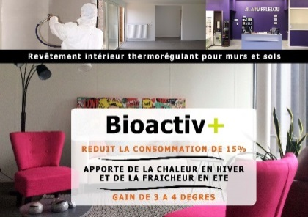

OUTDOOR FITTINGS

Company |  | DEHONDT COMPOSITES
Product name |  | NATTEX PANEL  The bio-sourced sandwich panels
Target | Architects, Engineering & design offices
Patent | Yes |  | Certification | Qualiflax 2017-002
Lauch date | March 2017

Product description

NATTEX Panel is a composite sandwich panel consisting of a foam or honeycomb core and bio-composite skins incorporating flax reinforcement fibers and a thermoplastic resin; possible dimension up to 2200 mm of width. Together, the Group offers users (fitters, industrialists) new generations of lightweight, recyclable materials with a reduced environmental impact. The use of flax fibers and biosourced materials, without fossil resources, ensures massive and recycling performance at the end of life of the completely innovative panels. These new panels have acoustic qualities and offer vibratory absorption. They favor a comfortable installation for the operators by their lightness, but also by the absence of emanation of VOCs and of toxic dust at the cutting. The post-oil era has arrived.

NATTEX Panel presents strength characteristics thanks to the technical flax fibre used in reinforcement. For the record, the flax fibre valued in this application is the long fibre with the highest mechanical characteristics of the plant fibres. The density of the flax fibre (1.45) is clearly lower than that of the fiberglass (2.45). The stiffness/mass performance ratio is superior to traditional plywood panels. The weight gain on a 15 mm thick wooden plywood panel is 50%. Flax fibres also provide acoustic and thermal insulation performance, as well as the intrinsic characteristics of natural fibres. The carbon footprint is favorable thanks to a short manufacturing circuit (100% French production and processing) and the use of biosourced materials.

NATTEX Panel fibre-reinforced sandwich panel is environmentally friendly, recyclable and design. Production and use are part of a sustainable development approach. The average weight of the panel is between 3 and 6 kg/m², depending on the configuration of the materials used for the core and skins; this allows the possibility of being used in places requiring structural alleviation, such as elevators, for example.
NATTEX Panel is a material that can be 100% biosourced, giving a mass gain of up to 50%.

The overall cost of NATTEX Panel is competitive compared to current technical products due to its continuous manufacturing process mainly. The raw material used, the flax fibre is a perennial local resource. The valorization of the panel at the end of its life is a strong environmental advantage in terms of the French and European regulations on the treatment of end-of-life materials. The LCA of flax fibre is very favorable (water consumption, carbon footprint...).

NATTEX Panel offers ease of handling and installation thanks to its lightness. An operator can easily manipulate this product, even of large dimension, of 1200 x 2500 mm. Manual cutting of the panel does not generate material that can cause toxic irritation or dust. The panel has a design surface where the flax fabric is visible. It can be tinted or integrated on its surface of decoration films ready for installation. All types of fixing are possible.
NATTEX Panel, by its lightness and its possible dimensions, offers a greater ease of implementation. Handling and possible cuts do not release VOCs or toxic dust. It is possible to install these panels without lifting tools. The panel can be designed and does not require painting.
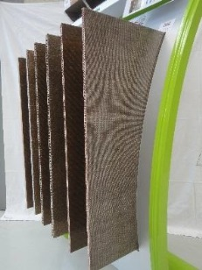

OUTDOOR FITTINGS

Company | ONLEVEL
Product name | KRONOS  The first adjustable glass clamp ever

Target | Architects, Engineering & design offices, Craftsmen / installers
Patent | Yes | Certification | Pending
Lauch date | September 2016
Product description

KRONOS by ONLEVEL, the first adjustable glass clamp ever. While developing this clamp, apart from the price, we always also had efficiency in mind. Creativity and innovation can only work if they go hand in hand with enthusiasm - on all levels: aesthetic design, efficient products and simple installation. This glass clamp is suitable for all relevant glass thicknesses: from 8 mm tempered glass up to 12,76 mm laminated safety glass thanks to its adjustability. It can be connected to all relevant post connections: flat back and 42 mm, 48 mm post (round). Considerably reduces inventory and technical support. The product is made in Germany and consists of top grade stainless steel and no unexpected widening and loosening of the grip – guaranteed. The screws are concealed by the desired cover for a clean appearance from both sides. The finishing will be 100% identical to that of the post or to the entire project, whichever the color.

All relevant glass thicknesses: from 8 mm tempered glass up to 12.76 mm laminated safety glass – instantly adjustable. All relevant post connections – flat back and 42 mm, 48 mm post (round). Considerably reduces inventory and technical support. Unsurpassed quality – top grade consistent stainless steel and no unexpected widening and loosening of the grip – guaranteed. Concealed screws – simply attach the desired cover – clean appearance from both sides. Simple installation – no longer do you require fiddly assembly of single components. Finish will be 100% identical to that of the post or to the entire project, whichever the color. Made in Germany - timeless precision and quality.Glass clamps is one of the most known items in stainless steel and China is the main producer. The production process being used is called casting. This is a high intensive production process which demands a lot of environmental resources and results in a high pollution rate.

Kronos is manufactured in Germany using a different green production process, called progressive stamping.
One clamp for all relevant glass thicknesses results in reduced stock investment and technical support. Unsurpassed quality – top grade consistent stainless steel and no unexpected widening and loosening of the grip – guaranteed. Concealed screws for a clean appearance from both sides, simply attach the desired cover in the desired finishing. And, as we think is the most important: an innovative production process that helps reaching the Paris Climate Agreement.

The benefit for the end user is the ease of installation, because Kronos consists of only 1 piece which is adjustable for all relevant glass thicknesses. This saves misunderstandings on the building site, as the glass thickness is not always known before installation. And since the screws are no longer visible on the outside, the design is also improved.The Kronos Glass Clamp consist of top grade consistent stainless steel: no corrosion guaranteed. Therefore the product is low in maintenance. If the glass has to be changed, this is easily done thanks to the adjustable clamp.
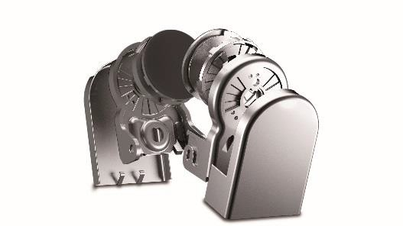
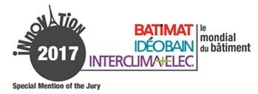
OUTDOOR FITTINGS

Environmental integration

Company | PISCINES DESJOYAUX
Product name | MOBIPOOL  The very first floating swimming pool in the world
Target | Project owners, Campsites, holiday resorts
Patent | Yes | Certification | n°160960-AVP-RAP-002 indice C
Lauch date | September 2015

Product description

Mobipool, the very first filtered floating swimming pool in the world, guarantees safe and clean bathing in a natural environment. Made up of aluminium pontoons, a filtration unit and a reinforced membrane, this floating pool comes in a range of sizes, from 6 x 3 m to 20 x 10 m. Thanks to the quality of the materials used, Mobipool is the perfect solution when seeking to enjoy all the benefits and pleasures of a swimming pool on an unused area, in safe and perfectly sanitary conditions.

The pontoons are made of aluminium to ensure that the pool stays afloat. The poles and cables to which the reinforced liner is attached are made of stainless steel. The liner is made of reinforced PVC, thickness is 150/100. Decks are made of non-skid EPDM rubber (ethylene propylene diene monomer) for a perfect finish and to prevent water from stagnating in crevices. The standard body rail around the pontoon is made of stainless steel cable to ensure a modern look. Mobipool by Desjoyaux is naturally equipped with a surface-mounted filtration unit from the Desjoyaux range. This type of filtration draws on 50 years' experience, and all the brand's technological breakthroughs. Our floating Mobipools can be equipped with two different types of filtration units: GR.I 181 for private use or GR.I 441 for collective use (hotels, campsites…).

Who hasn't dreamt of diving into a lake in the heart of nature? But seaweed and fish can be off-putting… For all those who want to be a water nymph without the inconveniences, Desjoyaux has developed an exclusive and cutting-edge solution: Mobipool! The concept is based on a modular pool in a natural environment for safe bathing.

Mobipool is a modular pool that can be installed right in the middle of an existing stretch of water. A totally new concept that will enable you to make the most of a pond or lake in total safety. The main advantage of our floating Mobipool is that it enables users to enjoy the water without having to worry about seaweed and all the other little inconveniences while enjoying the surrounding natural environment. Can be installed in just one day, depending on the size of the pool.
This product is beyond compare: there is nothing like it on the market.

Mobipool can be moved around to suit your requirements. It is also upgradable, as we can easily add modules or pontoons to increase the deck area.

Modular structures and pontoons can be assembled in just one day. Because Mobipool has been designed for use on ponds or lakes, the materials we use have been carefully selected to meet the constraints inherent to this type of environment.

WORKSITE EQUIPMENT & TOOL

Company | MESSER EUTECTIC CASTOLIN
Product name | DYOMIX® OHM 2.4  The innovative, mobile, safe oxy-flame station without gas cylinders!
Target |  | Craftsmen / installers
Patent |  | Yes | Certification | Pending
Lauch date |  | November 2017

Product description

CASTOLIN dyomix® OHM 2.4 is a breakthrough innovation that allows professionals to use a carbon-free, high-temperature flame without gas cylinders in applications requiring a torch! This CleanTech makes it possible to produce a clean and efficient combustible from water and electricity, by transforming into gases the oxygen and hydrogen naturally present in water. After having proved its worth to major industrial accounts, and after several years of R&D, the mobile version of the dyomix® technology, aimed at professionals, will be launched exclusively at the Batimat 2017 trade fair. Equivalent in size and weight to conventional oxy-gas stations, CASTOLIN dyomix® OHM 2.4 can be transported and moved easily with its handles and wheels. Its ergonomic torch, with a rotating connector connected to a single pipe, allows unrivaled freedom of movement.

CASTOLIN dyomix® OHM 2.4 includes an innovative process producing hydrogen and oxygen at a flow of 650L/h with an available pressure of 0 to 1.4 bar. Having the bulk of a cabin luggage, it has a 1 hour working autonomy at 100% of power between two refills. Small, compact, using little water and electricity, its maximum power of 2.4 kW and its high temperature flame of 2800°C make it a device with unrivaled performance. It also features intelligent electronic functions, such as an LCD display with real-time user messages, a production hour counter and a USB connection to update its software. The "explosion proof" design includes various safety elements such as self leak test and flame arrestor systems (ISO 5175 & EN 730).

Thanks to the on-demand production of gas, all the constraints associated with the use of gas cylinders are eliminated. The clean combustible, generated from water and electricity, can be used continuously thanks to a simple water recharge every hour. This makes it possible to have gas anywhere and anytime!

Created in 2009, dyomix® technology was developed and patented in partnership with the CNRS. After several years of R & D, its miniaturization allowed to propose an apparatus with the best weight, power and volume ratio of the market.

Experimented with recognized organizations, CASTOLIN dyomix® OHM 2.4 offers a 30% lighter torch and reduces the risks of MSD. The absence of UV emission, optical radiation and harmful smoke, a noise level lower than 25 decibels compared to the traditional systems allow to work without black glasses or ear plugs. On-demand production avoids the storage of flammable gas cylinders, thus improving safety conditions.

CASTOLIN dyomix® OHM 2.4 operates in on/off mode and the standard flame setting allows for immediate, simplified and non-adjustable use. The replacement of a refill takes 1 to 2 minutes versus 10 to 20 minutes with the conventional solution. It is done on site, at 0 km. It is easy to store safely in your utility vehicle enough water to work tens of hours without having to go to the gas depot (time saving) or store gas cylinders on the job site.

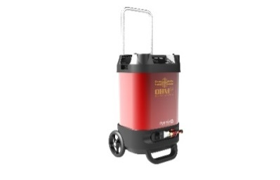
WORKSITE EQUIPMENT & TOOL

Company |  | DRONE VOLT
Product name |  | HERCULES 10 SPRAY  Spray Drone for buildings
Target | Craftsmen / installers, Roofers, Facility management…
Patent | Pending |  | Certification | Pending
Lauch date | January 2017

Product description

HERCULES 10 SPRAY is a professional drone for spraying liquid products with high precision for the construction industry. It allows precision treatment of hard-to-reach surfaces or hazardous areas such as roofs. The drone is fully operational in just a few minutes which reduces the amount of equipment to be deployed and the human risk associated with height interventions.

HERCULES 10 SPRAY makes operations efficient: thanks to its powerful pump, the HERCULES 10 SPRAY drone pulverizes up to 3 liters of liquid per minute. For roofs, facades and other surfaces, it allows a more effective result than a manual spraying. A fully foldable system: HERCULES 10 SPRAY arms are fully foldable, making the HERCULES 10 SPRAY ultra-compact for easy transport. Easily and rapidly operational: it’s operational in less than 10 minutes due to the use of less equipment than used with traditional manual methods. Operating costs: the HERCULES 10 SPRAY is designed to reduce operating costs. Reduces human risk: with the HERCULES 10 SPRAY, human risk associated with interventions of height is considerably reduced.

HERCULES 10 SPRAY results in a significant decrease in the time required to intervene on site. Its fast set-up also makes it possible to process a greater number of construction sites per day. These cumulative benefits allow a quick return on investment. Other advantages which should be highlighted are reduced maintenance and storage space but also the possibility to transport the drone in small vehicles. This drone is an innovative device for cleaning and treating surfaces, roofs, facades ... These missions were up to now carried out using traditional methods such as scaffolding, ladders, nacelles, …
For the operator, intervention time is reduced and consequently the operating cost decrease. For the final customer, the site's downtime is low and human risks are limited during procedures.

Using HERCULES 10 SPRAY drones gives companies a high-tech, innovative, cutting-edge identity, enabling them to be more competitive.

Interventions are fast, efficient and secure. The surface required for the deployment is small and the time spent on site is reduced.

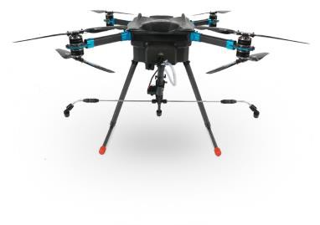

WORKSITE EQUIPMENT & TOOL

Company |  | ALSAFIX
Product name |  | LIGNOLOC®  The nails made of wood for pneumatic nailer
Target | Architects, Engineering & design offices, Craftsmen / installers, Project owners, Construction economists
Patent | Yes |  | Certification | No
Lauch date | May 2017

Product description

Lignoloc is a system of nails made of wood for pneumatic nailer. The nails are used as conventional nails for the assembly of two pieces of wood especially in applications such as wooden interior trim, wooden facades, wooden fences, natural furniture, sauna, floors, coffins, and many more to discover...

Lignoloc nails are made of German beech wood, are corrosion-resistant, can be machined and have a tensile strength of about 250 N/mm². With a diameter of 3.7 mm, Alsafix offers lengths from 50 to 65 mm packaged in plastic rolls at 15° inclination. Due to its nature, Lignoloc does not create a thermal bridge and does not require pre-drilling or glue. Due to the special characteristics of the Lignoloc nail tip and the high heat generated by friction when the nail is driven in, the lignin of the wooden nail fuses with the surrounding wood into a substance-free connection.

Lignoloc considerably reduces the presence of metal in wooden constructions.

Unlike traditional fastening methods, Lignoloc is the first fastener for wooden nailer, faster than a wooden anchor and less restrictive than a metal nail.

Lignoloc is fastened as fast as a metal nail and much faster than a wooden peg, with a final result in only wood is visible and present in the construction.

Only one operation is required to install Lignoloc. Lignoloc is fastened with a dedicated pneumatic nailer that works in the same way as traditional nailers, therefore with a very simple use for professionals.
Due to its very nature, Lignoloc will not need any additional treatment, it will resist corrosion, fungi and will not absorb water. Moreover, it can be cut with the same tools as for the cutting of wood.

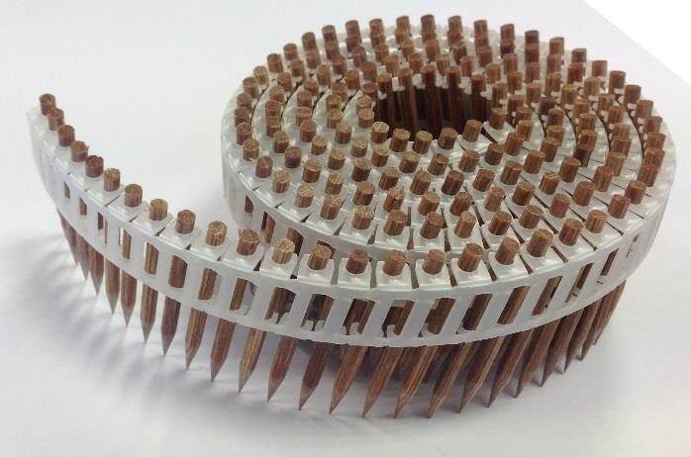

WORKSITE EQUIPMENT & TOOL

Safety and Prevention

Company |  | ROLIDE |  |  | 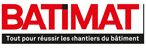
Product name |  | ROLIDE  The sliding floors for commercial vehicles
Target | Craftsmen/installers
Patent | Yes |  | Certification | FIA-17-004
Lauch date | January 2017

Product description

Rolide is an innovation in the sector of commercial vehicles and pick-ups. A patented solution to facilitate the loading and unloading of material, thanks to a sliding floor made in France, allowing a total extraction of the loading area with a load capacity of one tonne, compatible with all commercial vehicles.

Rolide allows a total extraction of the loading area and has a load capacity of one tonne and thereby respects the load capacities of commercial vehicles. It is compatible with all commercial vehicles of less than 3.5T. All mechanical parts and hardware are in stainless steel, the chassis is painted with epoxy coating, the profiles are made in aluminum and the plywood flooring is glued with a phenolic resin resistant to weather and boiling water. It meets the following standards: EN 314 / Class 3; BS 1203 / H4 (WBP); DIN 68705 Part 3 / Type BFU 100.

The 4 major benefits for the use of a Rolide sliding floor are: firstly the comfort since thanks to the Rolide, the climbing into the trunk is over, pull it out of the vehicle; secondly, the ergonomy as you optimize your work tools for better productivity and thirdly, the health because you preserve your health by avoiding bad postures. Lastly, your time that you save for your business.

The Rolide prevents the installer from climbing into the back of his vehicle in order to find what he needs and thereby losing time on his intervention. The fact that he no longer has to climb into his vehicle avoids MSDs (Musculo-Skeletal Disorders). This saving of time entails more productivity and consequently a saving of money. A faster intervention, a better access to loading for material and tools and an increase of the number of interventions and breakdowns per day.

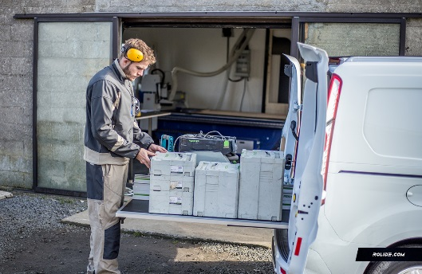

DIGITAL, BIM & NEW TECHNOLOGY

Company |  | LEICA GEOSYSTEMS
Product name |  | LEICA BLK360 IMAGING SCANNER  Imaging laser 3D scanner that anyone can use
Target | Architectes, Artisans/poseurs/installateurs, AEC
Patent | Oui |  | Certification | En cours
Lauch date | Mai 2017

Product description

Leica BLK360 captures the world around you with full-colour panoramic images overlaid on a high-accuracy points cloud. Simple to use with just the single push of one button, the BLK360 is the smallest and lightest of its kind. Anyone who can operate an iPad can now capture the world around them with high resolution 3D panoramic images. Using the ReCap Pro mobile app, BLK360 streams image and points cloud data to the iPad. The App filters and registers scanned data in real time. After capture, ReCap Pro enables point cloud data transfer to a number of CAD, BIM, VR and AR applications. The integration of BLK360 and Autodesk software dramatically streamlines the reality capture process thereby opening this technology to non-surveying individuals.

BLK360 imaging laser scanner will change the way you work, allowing you to capture accurate measurements efficiently and professionally. With a push of a button, you can scan an entire room in less than three minutes. Multiple scans will be automatically stitched together and registered in Recap Pro for mobile. This simple scan captures your surrounding environment in precise detail with up to 65 million surveyed 3D scan points. The imaging laser scanner not only provides you fast full 360° panoramic HDR imagery, it will also capture millimeter accurate 3D measurements with up to 60m range in radius. BLK360 also comes with an integrated Thermal Camera capturing a thermal panoramic image with a 360° x 70° field of view. This captured data will allow you to build the most accurate 3D model, and design with confidence.

Borrowing from 200 years’ experience in precision measurement, Leica Geosystems combined sensors in an innovative system which weighs about 1kg.

With a price tag of only 15.000 EUR the Leica BLK360, is currently the most cost effective high end 3D imaging laser scanner in the world. Most of its competitors would sit in a price range double as much as the Leica BLK360. With such a low price Leica for the first time lowers the barrier of adoption to a point where everybody can afford 3D Laser scanning technology. It will also allow most customers to have a full return on investment already after a very short amount of time.

Besides all the benefits such as price, size, weight and the ease of use the Leica BLK360 will change the way people with capture reality. The device comes with a one-button push operation and is also easily controlled via an iPad Pro. The system will get you the “digital fingerprint” of the reality with up to 60m range in radius.During the construction of a house or building the Leica BLK360 will provide a complete documentation of all construction phases. No detail will be missed, even in very complex environments such as boiler rooms or hard to reach environments.
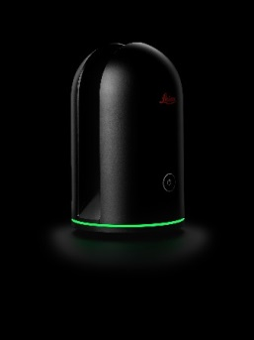
DIGITAL, BIM & NEW TECHNOLOGY

Company | ABVENT
Product name | TWINMOTION 2018  The real-time Archviz and VR exploration software
Target | Architects, Project owners
Patent | No | Certification | No
Lauch date | July 2017

Product description

Twinmotion is a unique, 100% real-time and multi-platform 3D immersion software, designed especially for project owners, contractors, architects, construction professionals, space-planners, urban planners, and/or real estate planners, who wish to value and explore their project, simulate, show and demonstrate, communicate and share - in short: convince!

Whatever the size or complexity of the project, on Mac or PC, or equipped with VR headset, HTC Vive and Oculus Rift, Twinmotion brings to life and animates any type of project in its complete and dynamic environment, existing or created, and renders within seconds, fixed images, panoramas and standard or stereoscopic videos of a very high quality. Twinmotion manages the 3D models of almost all modelers on the market and benefits from direct synchronization - unique in the world - with the two market leaders (ARCHICAD and Autodesk Revit).

Powered by the award-winning American virtual reality engine Unreal, Twinmotion combines performance across all platforms (Mac or PC): calculation speed and rendering (within seconds!), very high quality, consistently high level, mobility. Its interface, like its tabs and pictograms, are pure, clear, very easy to memorize and manipulate; the user is guided step by step in the construction of his scene. Twinmotion is compatible with all the modeling software on the market and offers direct synchronization with ARCHICAD and Autodesk Revit. From the insertion of the project in its environment (existing or created) to the production of renderings, videos, 3D videos ... through the evaluation of multiple concepts, the enrichment of the project or the personalization and the animation of the entire scene (climate, terrain, characters, vehicles, plants ... thanks to a library of more than 1600 objects) everything is done in real-time and instantly visible: even in preview mode.

Twinmotion makes it possible to win on all levels: to evaluate your projects, to be fast and responsive (in manipulation as in rendering), and thus save time and money, be confident because you are using state-of-the-art technology, extremely simple to learn and manipulate, without any hardware or software investment.

Available under a perpetual, single user and/or network license, the 2-or-3-year Twinmotion Contract of Services implemented by Abvent allows the user to benefit, throughout the duration of their contract, from many advantages, including product updates.

Renderings, videos and other self-executable files (known as BIMmotion), which are also readable on tablets, offer the possibility of synchronizing with the BIM model on site, and assist in finding and solving clashes, simulate new ideas on site, present and explain the design.
Synchronization with the BIM model allows the designer to make specific renditions of the HVAC system; specifically, for the facility managers who will be able to visualize the source of a given incident and intervene more quickly. Twinmotion has proven to be a valuable tool in many situations. For example, for gendarmerie/police security training, and also for the fire safety of Aéroports de Paris.

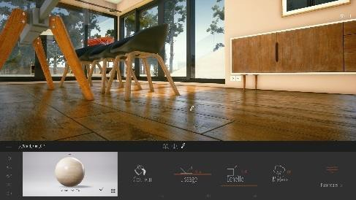
DIGITAL, BIM & NEW TECHNOLOGY

Company |  | DOKA FRANCE
Product name |  | CONCREMOTE  The real-time concrete on-site monitoring solution
Target | Craftsmen / installers
Patent | No |  | Certification | ISO 17025 (ISO de laboratoire)
Lauch date | September 2017

Product description

Concremote is a monitoring digital system able to determine the concrete strength in real-time on the jobsite with measuring sensors in the concrete. The measured data from the structure member are transmitted to the Concremote digital platform. The Concremote software continuously provides to its users the data regarding the evolution of temperature and therefore the concrete maturity and strength. Like this, Concremote allows to control, optimize, document and justify the targeted formwork and concrete pouring works on site. It’s used for any construction with cast-in-place concrete, whether it’s a slab, fair-faced concrete, climbing formwork or tunnels for instance.

Two types of sensors are used: sensors for slabs, placed on the concrete and cable sensors fixed to the Doka wall formwork. These sensors measure the temperature of the concrete at regular intervals and transmit them to the Concremote computing centre. At the computing centre, the data are automatically evaluated by the maturity monitoring method, using calibration measurement. A separate calibration measurement is needed for each different grade of concrete to be measured at the site. Via the user-optimised, web-based programme, the jobsite can access the data at any time and/or receive by email or by SMS the information regarding the evolution of maturity and the reach of the target strength in real time. This information permits taking numerous decisions for the next works: when to start the next climbing, to strike the formwork or to authorize a load or flow over the construction, how to optimize the concrete formulation or to adapt it to the specific conditions of the jobsite.

Besides this information usually useful, Concremote provides essential indicators for the critical construction works: for instance, to learn the required strength for the cable tensioning of a post-tensioned slab, to manage fair faced concrete or to guarantee a constant concrete color, to know when to climb the platforms of a climbing formwork, when it’s about thick slabs and long spans… These information are essential to guarantee the performance, quality and safety of the jobsite. The computing centre receives the data measured on site via the mobile communications network and then uses them to calculate the concrete strength by comparing it to that of reference concrete cubes in the calibration box. Each concrete formulation is actually analyzed through a reliable procedure based on the maturity method by De Vree. Therefore it’s not about trusting empirical assessment but taking decisions based on measured and documented data.

Concremote makes it possible to improve the control of formwork and pouring operations, to minimize cycle times and commissioning quantities, a more accurate management of curing times, to control and document the quality. With Concremote, the whole construction process is optimized interactively, from the tender phase to the construction and maintenance and final recycling.

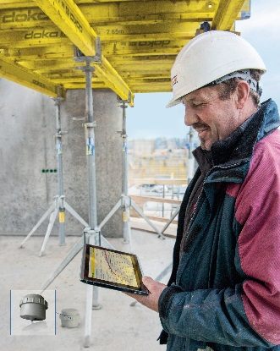
HVAC

Company | LUFTMEISTER
Product name | LUFTMEISTER  The system which distributes ventilation costs by measuring energy consumption
Target | Architects, Engineering & design offices, Craftsmen / installers, Project owners
Patent | Pending | Certification | Pending
Lauch date | November 2017

Product description

Luftmeister is the world's first air energy meter. In other words: for the first time in HVAC history, it is possible to meter what is delivered by an air conditioning unit - to each individual consumer. Based on a precise mass flow and enthalpy measurement, Luftmeister is able to meter how many cubic meter of air each consumer has consumed. Furthermore, Luftmeister sums up the amount of delivered energy - separating into cooled and heated air. This is relevant, as cooling is mostly much more expensive than heating. So last but not least, every consumer pays for what he consumes, leading to a situation of fairness, a clarified juridical situation without doubts and unpaid bills.

Luftmeister is a measuring solution of high precision which leads to energy saving in shopping malls or office buildings. And last but not least, Luftmeister is easy to mount in new and existing air ducts.
Luftmeister's high measuring precision, but also its safety features to prevent manipulations or loss of data, will bring a high acceptance with both supplier and consumer of air.

Up till now, there is no meter for consumption based on the attribution of ventilation cost. So the general idea is already very innovative. Furthermore Luftmeister's concept to measure flow of energy and to be able to distinguish between cooled air and heated air is highly innovative - several patents are pending.

There are no comparable product so far. Compared to an average air conditioning which costs €8,000 per year, with a minimum time of use of 5 years (can be 20), the price of around €1,800 per Luftmeister is economically very reasonable.

The individual shop owner (in a shopping mall) or office owner (in a multi-party office building) receives a fair and clear ventilation bill and does not pay for his neighbor's waste of energy. Furthermore, Luftmeister gives him a continuous monitoring of how many air is supplied to his area and at what temperature - helping to avoid shortages in air supply or for example too hot supply air in the summer. This will make his area more attractive - both for his employees and customers.

The installer has the benefit of easy mounting, both in retrofit and in new air conditioning plants.
Luftmeister is easy to calibrate and does not request maintenance.

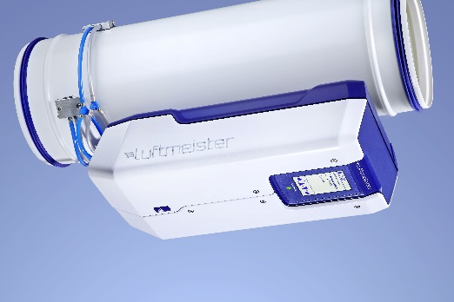
HVAC

Company |  | UBBINK FRANCE |  |  | 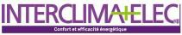
Product name |  | ROLUX RENOFIT®  The horizontal terminal for renovation Ø60/100
Target | Craftsmen/installers
Patent | No |  | Certification | DTA 14/16-2209
Lauch date | September 2016

Product description

ROLUX RENOFIT® RENOFIT® is a renovation terminal designed for the gas flue evacuation of gas condensing boilers. Clever, Renofit avoids an external intervention of a rope technician or the use of an aerial basket, because it allows to use the external part of the existing horizontal terminal.
ROLUX RENOFIT® is used for the replacement of an old non-condensing gas boiler by a condensing gas boiler. The reuse of the external pipe of the existing terminal avoids heavy masonry work or the use of important human and material resources. The seal ring system prevents from rain water infiltration and ensures a perfect airtightness. Manufactured in Polypropylene and UV resistant, Rolux Renofit is very resistant to abrasion and impermeable.

The advantages of ROLUX RENOFIT® are double: easily adaptable on most of the condensing gas boilers, it allows to decrease most of installation costs (a single installer, neither aerial basket nor rope technician) and to reduce the constraints linked to a renovation site (neither loosening nor rubble).

The ROLUX RENOFIT® is innovative in its ease of installation: a single person can install it without outside intervention (nacelle or cordiste). Furthermore it allows not to damage the wall and its environment by using the former pipe: no works of masonry are to plan.

The ROLUX RENOFIT system® is made by system of plastic injection. The industrialization of this product thus allows to supply an inexpensive product at the same time for the installer and the user. Furthermore, its installation does not require rent of nacelle, decreasing strongly the cost of installation of the terminal.

RENOFIT® was designed to keep the performances of the boiler while reducing the costs of its installation. The installation is fast and without works of masonry: it facilitates the lives of the inhabitants of the accommodation.
The ROLUX RENOFIT® brings a big ease and speed of installation thanks to an intervention from the premises and not from the outside. The use of a part of the former system thus limits the works on the wall (core drilling, drilling). The installation time of the terminal is very fast: 15 minutes are enough!

RENOFIT® is available in the form of complete kits (terminal, wall plate, bend and flenge). The stages of installation are printed on the packaging and the QR code allows to reach the video of installation: the company of maintenance is accompanied in its intervention.

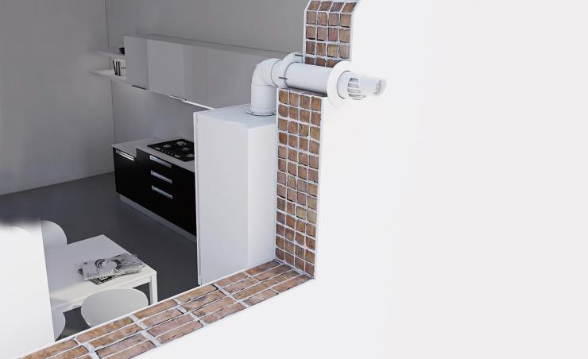
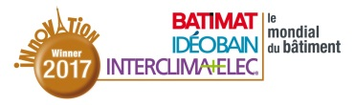
HVAC

Company |  | WEISHAUPT
Product name |  | WM-G20 ZM-PLN  The premix Ultra Low Nox burner
Target | Engineering & design offices, Craftsmen / installers
Patent | No |  | Certification | CE-0085BQ0032
Lauch date | March 2017

Product description

WM-G20 ZM-PLN Premix Ultra Low NOx is a forced-air surface-stabilised combustion gas burner with a maximum thermal output of 2500 kW. The WM-G20 ZM-PLN burner is available in two versions, the WM-G20/2-A for a capacity range of 180 to 1750 kW and the WM-G20/3-A for a capacity range of 250 to 2500 kW. This burner is fitted on low-temperature and condensing heat generators for tertiary and industrial applications, where particularly strict NOx requirements are demanded. This burner, in part designed for revamping, is versatile and can be adapted for heat generators with extremely small combustion chambers, either three-pass or reverse flame technology. This burner, which uses natural gas or LPG, is fully automatic and controlled by a combustion manager. It is supplied along with its gas valve train. Easy to commission and run, the WM-G20 ZM-PLN is the solution to ensure reduced NOx production and so preserve the planet.

The Ultra Low NOx burner, guaranteeing < 10 ppm (< 20 mg/kWh) of NOx emissions for natural gas over a wide modulation range (1 to 10) and on all types of heat generator technology, even on small combustion chambers. It relies on the Premix combination and surface-stabilised combustion via a combustion tube covered by a microweave alloy mat on which a uniform flame carpet is generated. The separate flow of gas and air excludes any inflammable mix in the burner and so guarantees reliable and completely safe operation. A dual device for air filtration and inlet control ensures air quality free of any impurity. This new Premix concept enables a noise level attenuation of 10 to 15 dB(A) on the flue gas circuit. The WM-G20 ZM-PLN enjoys digital combustion management via a combustion manager, which provides all the safety and control functions for ensuring efficient combustion.
Unlike "conventional" Low NOx burners, where air and gas is mixed at the combustion head and the internal flue gas recirculation needed for NOx reduction is in part linked to the heat generator, the innovative concept of the WM-G20 ZM-PLN Premix burner is based on premixing the air and gas upstream from the surface-stabilised combustion. The Low NOx flame carpet generated on the surface is fully independent from the heat generator and gives an even greater reduction of NOx emissions.The cost of the WM-G20 ZM-PLN Premix burner is kept fully under control and in line with the environmental constraints required. It involves a cutting-edge technology reserved for sites prioritising environmental issues. A large number of mechanical, electrical and electronic components are the same as in "conventional" burners, a guarantee of durability and reliability over time. This technology is adapted to any type of heat generator and enables the installation to be made compliant at a lower cost by simply replacing the burner with a WM-G20 ZM-PLN burner, without any need to invest in a new boiler. The sleek look and use of high-quality materials mean this efficient burner's innovative design will aesthetically enhance boiler rooms, as well as making them environmentally friendly.

All the mechanical, electrical and electronic components in the WM-G20 ZM-PLN burner are easy to access and have an electrical connection via a foolproof plug to avoid any possible source of errors. The potentially dangerous parts are not accessible and deliberate action is required to do so. The display and control module and the precision of the technical data included in the Weishaupt manual ensure user-friendly adjustment and configuration of the burner. The display and control module enables the nature of any malfunction to be identified. Running costs and implementation are the same as for classic burners.
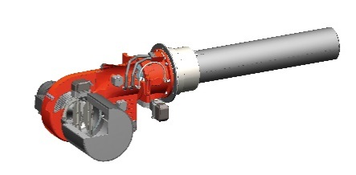

RENEWABLE ENERGIES SYSTEM

Company |  | AIRMAT
Product name |  | COMPACTE ENERGIE +  The air/water heat pump with free hot water in cooling mode in the summertime
Target | Architects, Project owners
Patent | Pending |  | Certification | Pending
Lauch date | November 2017

Product description

COMPACTE ENERGIE + is an air/water heat pump, split system, double service, for single houses, which produces in the winter heating through underfloor heating, radiator and/or fan-coil, and produces domestic hot water (DHW) in 150, 200 or 300L tanks. In the summer, it produces DHW and cooling through underfloor cooling and/or fan-coil. In heating mode, the indoor unit condenser heats the heating water, and the outdoor unit evaporator refreshes air to recover energy. Conversely, in cooling mode, the indoor unit evaporator refreshes water and the outdoor unit condenser heats air to recover energy. The innovation is that the heat pump produces free DHW when in cooling mode, by recovering the heat emitted by the condenser to produce cold which is wasted in regular heat pumps.

COMPACTE ENERGIE + is fitted with an extra heat exchanger, in the guise of a hose tightly coiled around the tank, in order to heat DWH when in cooling mode. The yield of the COMPACTE ENERGIE + is higher than that of standard heat pumps because DHW production doesn't use energy when in cooling mode.

The RT2012 Cep requirement is about 50W/m² primary energy for heating, DHW, cooling, lighting, ventilation and auxiliaries, and sometimes, you can't implement cooling in new houses because the consumption is too high. With the COMPACTE ENERGIE +, one can cool without extra energy consumption because it recovers energy for DWH. It is a real advantage for the user.

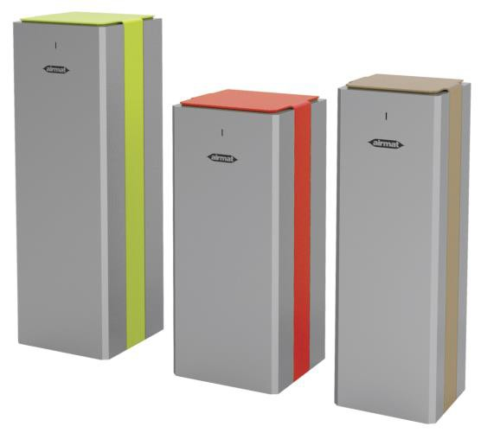

BATHROOM PRODUCTS

Company |  | SFA |  |  | 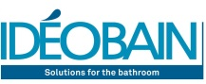
Product name |  | SANIPRO® XR UP  The macerator that allows the creation a new bathroom, anywhere
Target | Craftsmen / installers
Patent | Yes |  | Certification | FR_700791
Lauch date | January 2017

Product description

SFA products allow to lift used water up to the sew from rooms away from the waste stack. Among these solutions, SANIPRO® XR UP is the best one to answer to high standard requirements. Turning a garage in to a brand new bathroom? Now it is possible with SANIPRO® XR UP. Its 4 inlets allow it to deal with a WC, a wash-basin and a shower. Thanks to the macerator inside, the evacuation is made through a reduced diameter, for a discreet installation. Easy to maintain, noiseless, and highly efficient, SANIPRO® XR UP is the best way to create a new complete bathroom without major work.

SANIPRO® XR UP enables discharge up to 5m verticaly or 100m horizontaly. It incorporates the silence technology (46 dB(A)) for discreet uses. It requires an 220-240V / 50Hz eletrical outlet to be installed (motor power 400W). Central basket access is possible through the upper hatch. The maintenance is highly facilitated : the plumber no longer needs to dismantle the machine and/or to empty the bowl. The non return valve and the active carbon filter ensure a totally hygienic use. The macerator keeps the same dimensions as before and the replacement of an old model is possible.

The "UP" technology is a SFA revolution. Actively listening to our installers' feedback allowed us to identify improvement levers regarding the maintenance of our old models. To answer this basic need, we created the "UP" technology : a hatch on the upper part of the device has been added in order to facilitate access to the central basket and to the macerating system.

The plumber does not need to dismantle the machine and/or to empty the bowl anymore! Central basket access is a true innovation for SFA macerators. 80% of identified breackdowns are due to objects stuck in the macerating system. Installers used to pull the whole toilet away from the wall, and then dismantle the macerator. This innovation facilitates the plumber's task and reinforces the possibility for the client to be able to create and to maintain a new bathroom without major work.

SFA descaling agent enables to keep products in operating condition beyond these 5 years. Provided with connecting pipes, carbon active filter and the non return valve, SANIPRO® XR UP represents a profitable investment for the final user.

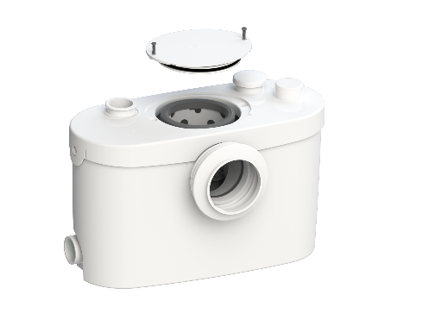

BATHROOM PRODUCTS

Company | GROHE
Product name | GROHE SENSE GUARD  The devices detect, leaks, pipe breaks and floods - Before a drip becomes a flood
Target |  | Engineering & design offices, Craftsmen / installers, End-users
Patent |  | Pending | Certification | No
Lauch date |  | September 2017

Product description

Designed, developed and manufactured in Germany, GROHE SENSE GUARD is an intelligent connected system that independently controls water consumption, detects leakage, measures humidity and temperature changes that could damage your equipment. In case of pipe breach, the SENSE GUARD will automatically turn off the water supply. As soon as the SENSE sensor is in contact with the water, it produces an audible signal. Wherever you are, thanks to the GROHE ONDUS application, you will receive a notification on your smartphone so as to react as soon as possible.

The devices detects, leaks, pipe breaks and floods. They alert immediately with an audible and bright signal, send a push notification to the smartphone via the Ondus application and instantly shut off the water supply.

The sensors measure once every hour the humidity level and the temperature, so they anticipate the risks of frost.

AquaAlarm: receive situation-dependant alerts (pulsating red light, beeping sound) or on your smartphone.

AquaIQ: the self-learning algorithm ensures that all alerts and actions are perfectly adapted to match your household consumption.

AquaBlock: shuts off the water supply either manually or automatically in case of a pipe break.

AquaTrack: tracks your daily water consumption accurately.

GROHE SENSE GUARD makes it possible to pilot remotely and securely your home's water supply. The sensors also monitor and measure temperature and humidity in rooms.

The sensors paired with GROHE SENSE GUARD allow simple and intuitive control of potential water-related damages via a single application: GROHE ONDUS.

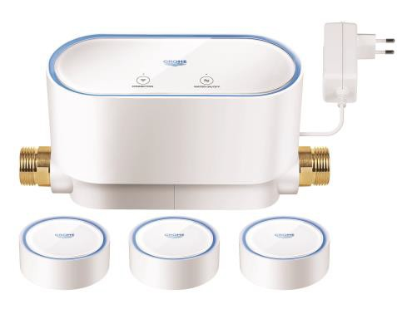

BATHROOM PRODUCTS

Company | NICOLL
Product name | DOCIA®-XS AVEC TECHNOLOGIE MAGNETECH  The first compact trap for tiled shower, with the patented magnetic technology
Target |  | Craftsmen / installers
Patent |  | Yes | Certification | Pending
Lauch date |  | October 2017

Product description

DOCIA®-XS by Nicoll is the first trap combining compactness, performance (high flow rate, anti-odour) and durability so much demanded for a tiled shower. Thanks to his 60mm height only, it meets the requirements in new buildings in case of low recess or in refurbishment by limiting the recess needed. This trap benefits from the MAGNETECH technology, a magnetic valve + counter-valve technology, unique and patented by Nicoll. This non-mechanical concept, combined with a limited water seal height ("DUAL-SYSTEM") brings a life-time guaranteed performance to the end-users: the magnets are for ever. The full access to the waste pipe and the absence of retention area (magnetic valve in suspension) gives to the trap a unprecedented resistance to clogging. This innovation combined with the co-injection of all the gaskets, prevents any risk of odour while ensuring a high flow rate.

The design of the Nicoll DOCIA-XS trap with removable magnetic valve and reduced water seal height ensures a very low overall height, which is a must in case of low recess or in refurbishment, while guaranteeing high performance and durability demanded by the end-users. The magnetic valve in suspension without area of retention, brings an unprecedented resistance to clogging. The valve with co-injected seals blocks odours whatever the pressure/depressure in the waste-water piping. The high opening capacity of the valve ensures a 0,6L/s flow rate. The large flange with clamp & stainless steel screws ensures a perfect watertightness between the trap and the waterproofing system of the shower area, ensuring durability of the installation. The "push-corner" system allows, by a simple finger push on an angle of the grid to slightly lift it, facilitating the removal, and enabling an access inside the trap.
The first trap for walk-in shower, combining low height, high flow rate and resistance to odour thanks to its MAGNETECH Dual system magnetic valve. The absence of friction/contact between the valve (in suspension thanks to the attraction strength from the magnets) and the rest of the components, avoids any dysfunction or clogging because of dirt.The SFH Docia-XS innovates through the MAGNETEC technology, a magnetic anti-odour valve + counter-valve. Combined with a reduced water seal height and with the built-in gaskets, it ensures absolute performance and durability. The low-height traps on the marketplace benefit from a limited water seal height, a mechanical valve or a dry water seal with membrane bringing no optimal long term guarantee of use: clogging, siphonage, odour, mechanical systems wearing out.
This trap also benefits from a waterproofing system, with an upmarket finish level, and a wide choice of stainless steel grids. The added-value of Docia-XS Magnetech lies undoubtedly in its performance and durability, 2 users' needs currently unmet by the existing low-height traps.With Docia-XS Magnetech, the end-user is assured of an optimal comfort and well-being in his walk-in shower: a high water flow rate (without risk of flooding) and no unpleasant odour. He can choose the finish among a wide variety of Designer stainless steel grids or a to-be-tiled grid to match the atmosphere of the bathroom. The "push-corner" system of the grids enables him to access inside the trap without any tool for an efficient cleaning.With Docia-XS Magnetech, the installer enjoys a low-height trap, which avoids him to make a significant recess under the trap when the depth is not sufficient for his installation. The solvent-welding connection enables a perfect and reliable connection to the network. The flange with clamp & screws in stainless steel enables him to adjust the height of the trap depending on the kind of flooring.
The maintenance company is given a full access to the soil pipe for an efficient and quick cleaning in case of need. The usual cleaning remains the end-user's duty. A simple cleaning by rinsing the removable valve and counter-valve is to be carried out within a normal use of the shower place.

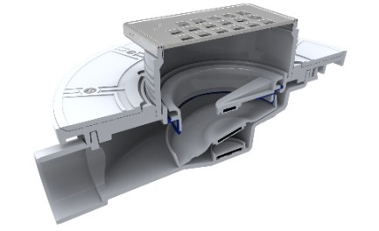

* Members of Le Mondial du Bâtiment Innovation Awards Grand Jury

Emmanuel Acchiardi, Sous-directeur de la Qualité et du Développement Durable dans la Construction, DGALN/DHUP/QC - Gilles Aymoz, Chef du Service Bâtiment à la Direction Villes et Territoires Durables, ADEME - Bernard Brandon, Directeur Général, CETIAT - Marie-Laure Barriera, Directrice des rédactions, Zepros - Cesare Casati, Directeur de la publication, L’ARCA International - Bertrand Delcambre, Président du PTNB (Plan Transition Numérique dans le Bâtiment) - Agnès Denoix-Molina, Rédactrice en chef, Technic’Baie - Stéphanie Dreux-Laisné, Directrice de la publication L’Echo de la Baie - Michel Droin, Entrepreneur et membre du Comité exécutif de la Fondation FFB, FFB - Kizito Ngoa, Président de l’Ordre National des Ingénieurs de Génie Civil du Cameroun - Grégoire Noble, Journaliste, chef de rubrique Innovation, Batiactu - Stéphanie Obadia, Rédactrice en chef adjointe, Groupe Moniteur - Sebastian Redecke, Rédacteur en chef, Bauwelt - Gérard Sandres, Responsable de domaine Documentation Technique, OPPBTP - Nejib Snoussi, Directeur Général de l’Habitat, Ministère de l’Equipement, de l’Habitat et de l’Aménagement du Territoire de Tunisie - Frédéric Taddeï, Directeur de la publication Verre & Protections Magazine - Mame Traoré, Responsable Marketing et Communication, Groupe Batiweb.

Kontakt dla prasy

Manager ds. komunikacji międzynarodowej
Reed Expositions France
Carine Bogusz / carine.bogusz@reedexpo.fr

Przedstawicielstwo targów Mondial du Bâtiment w Polsce :
Międzynarodowe Targi Francuskie
Warszawa, tel. 22 815 64 55 fax 22 815 64 80 e-mail : promopol@it.pl

REED EXPOSITION FRANCE - www.reedexpo.fr
Działając w 20 sektorach, organizując 52 imprezy targowe będące liderami w swojej branży m.in. Batimat, EquipHotel, IFTM-Top Résa, Expoprotection, Pollutec, Midest, SITL, Maison & Objet*, Fiac, Paris Photo, Nautic… i prowadząc 51 stron internetowych Reed Expositions dostarcza swoim klientom sieci kontaktów i możliwości do rozwoju ich działalności. Ponad 24 400 firm i 1,58 miliona profesjonalistów z Francji i z zagranicy współpracuje z nami przy organizacji imprez targowych.
Reed Expositions jest częścią grupy Reed Exhibitions, największego światowego organizatora imprez targowych i lidera na rynku francuskim, który reprezentuje ponad 60 wydarzeń i posiada dwie filie : Reed Expositions France i Reed Midem.
*organizowane przez SAFI, filię Reed Expositions i Ateliers d’Art de France

